# **BURNEO ESPIN DANNY JESUS**

# **MOCKUP DEL PROYECTO**

## VISTA EN PAGINA WEB

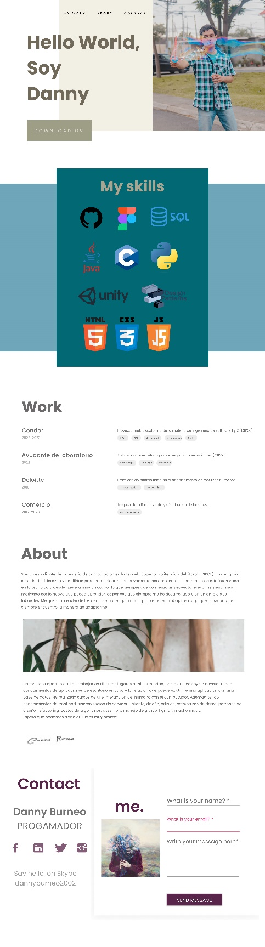

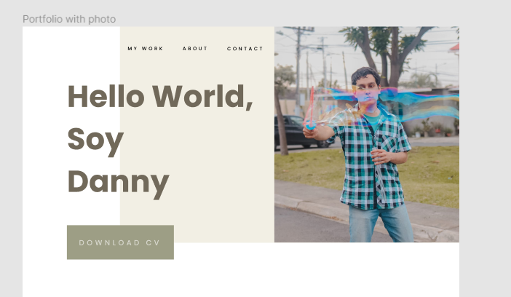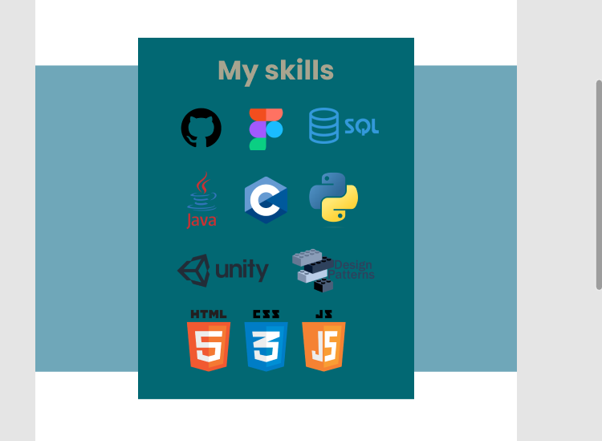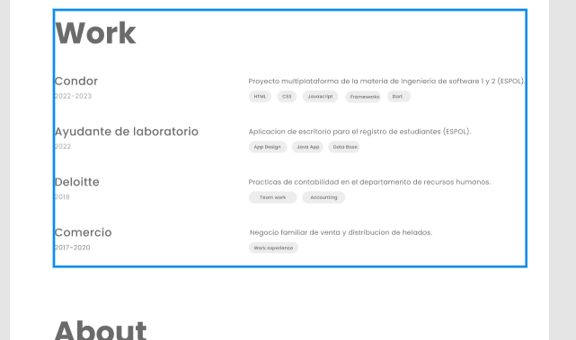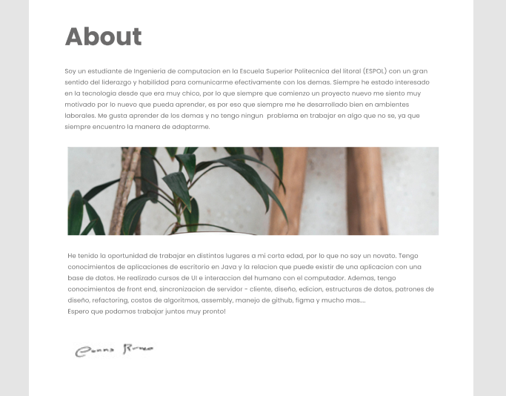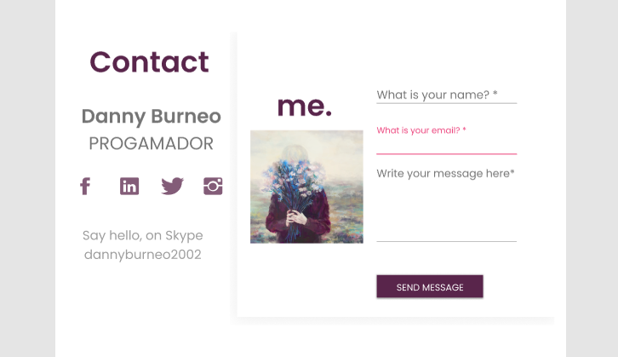

## VISTA EN DISPOSITIVOS MOVILES

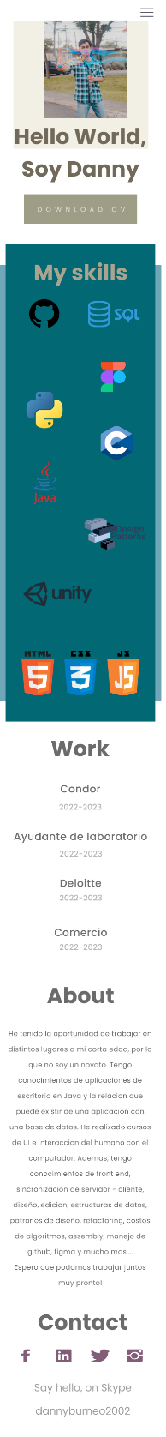

**COLORES USADOS**

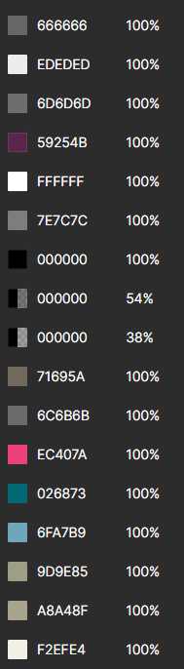

**FONT USADO:**

**Poppins.**

## LINKS DE INSPIRACIONES

<https://www.figma.com/community/file/1094170020258746178>

<https://www.figma.com/community/file/1119552594263324105>

<https://color.adobe.com/es/create/color-wheel>

<https://www.figma.com/community/file/1055793767573657793>

https://www.figma.com/community/file/883766363000361657